Integrating the Arts
www.integratingthearts.yolasite.com
By: Carol Schneider
Title: Rocks and Minerals Concrete Poem
Grade Level: 5th
Subject: Science/Language Arts
Content Covered: Rocks and Minerals
Materials Needed:
- Paper
- Pencil
- Computer
Procedure:
- Explain to students that a concrete poem is just a poem written in a shape. They don’t have to rhyme but can if you want them to. Show examples from concrete poems on Google images.
- Explain that since they are studying rocks and minerals in science they are going to create a concrete poem on rocks or minerals. Have them look at different images of rocks and minerals on Google images. Tell them to make their poems in the shape of a rock or mineral of their choice.
- Tell students to use their imagination, but the poem needs to include information regarding rocks or minerals.
Extensions:
This lesson can be adapted to fit any content in any subject. Examples: Settings, character, places, things, etc….

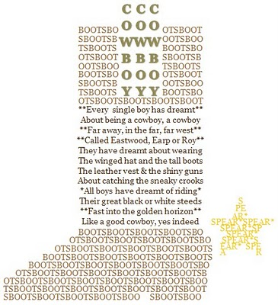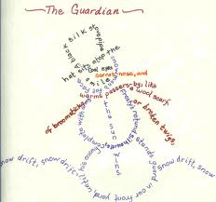

Assessment:
Concrete Poem Rubric
 | 3 | 2 | 1 | Total
Shape | The poem is in the shape of a recognizable object. | The poem is in the shape of a somewhat recognizable object. | The poem is not in the shape of a recognizable object.
Rocks or Minerals | The words mostly include information about rocks or minerals. | The words include some information about rocks or minerals. | The words include very little information about rocks or minerals.

Total________________/6.
Teacher Comments:
My students loved creating these poems. They came up with some amazing shapes and poetry. I framed the poetry in colored paper and displayed them in the hallway.
Resources:
This lesson is adapted from Lesley University Instructor of The Language of Poetry professor Christina Burress.

