Integrating the Arts
www.integratingthearts.yolasite.com
By: Natalie Paasch
Title: Passage Found Poem
Grade Level: 5th
Subject: Science (any subject area will work)
Content Covered: Erosion (any content area will work)
Materials Needed:
- Passage about content such as erosion, however any content will work
- Scissors
- Glue
- Magazines
- Large construction paper
Procedure:
- Explain to the students that they are going to make a found poem. A found poem uses only words/phrases from an already created passage. They may use the words in the same order they found them in the passage or they make mix up the order. It is best to read through the passage and pick your favorite words before deciding on a poem topic. Your poem does not need to be related to the topic of the passage. It can be a completely unrelated, new topic. Be creative.
- Pass out a passage to each student and have them begin cutting out the words they like.
- Have the students arrange their words to make a poem. Encourage them to design their words in a pattern or shape that enhances their poem. The sample below is a poem about a river, the passage had nothing to do with rivers, and the words are arranged to look like a winding river.
The River
Found Poem from “I Use to Live Here Once” by Jean Rhys

The river,

Unsteady

flowed over carelessly

and tramples extraordinarily

turned the corner,

wider, but stretched away,

towards the big white blood hot sunlight

instinctively straight into her sides

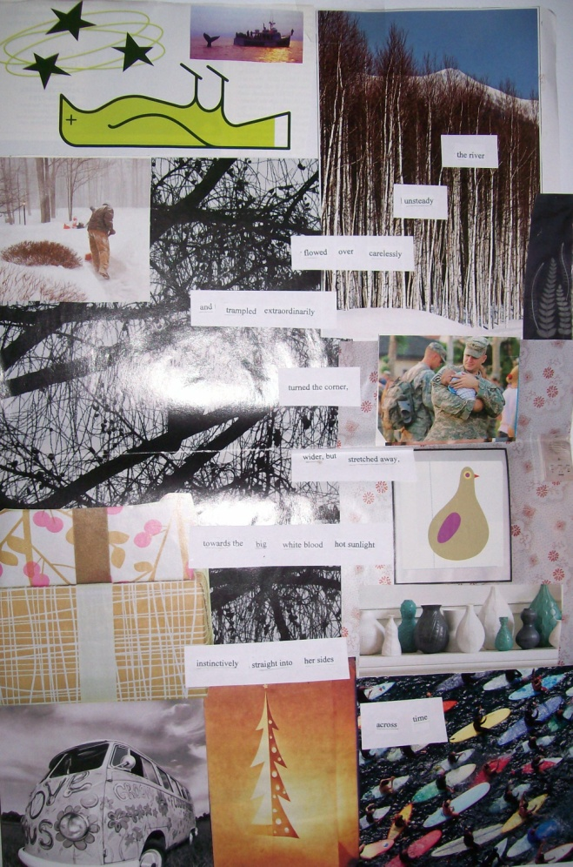
- Now have the students design a collage background using magazine clippings. Encourage them to cover all the white space and overlap their pictures. The pictures can be related to their poem to enhance it or it can just be of things that intrigue the student. The sample below is unrelated to the poem.

- Have the students paste their clippings on the large construction paper and then paste their words on the collage.
- Allow time for the students to present their found poems to the class.

Assessment:
Passage Found Poem Rubric
Poetry | Novice | Apprentice | Veteran | Master | Score
Ability to captivate the reader | Unfocused; author seems unsure of direction  (1-2 pts.) | Some focus, but lacks continuity  (3-4 pts.) | Well focused and interests reader throughout.  (5-6 pts) | Captivates and involves reader deeply.  (7-8 pts)
Sensory Images | Difficult to visualize image or emotion  (1-3 pts) | Some use of image, idea, or emotion  (4-6 pts) | Clear use of sensory images to portray ideas or emotions  (7-9 pts) | Vivid, detailed images and intensely felt emotion  10-12 pts)
Effort | Very few magazine cut outs and very short poem  (1-2 pts) | Either great collage with lacking poem or lacking collage with great poem  (3-4 pts) | Collage mostly correlates to the poem  (5-6 pts) | Collage is full and compliments the creative poem very well  (7-8 pts)
Punctuation | Arbitrary punctuation  (1-2 pts) | Some meaningful punctuation  (3-4 pts) | Punctuation meaningful throughout  (4-5 pts) | Punctuation enhances conveyance of thoughts and images  (5-6 pts)

Total Score: __________/34
Comments: ____________________________________________________________________________________________________________________________________________________________
Extensions:
This lesson can be adapted to fit any content in any subject area. Examples: Take a passage from the weekly reading story, take a passage out of the social studies book, take a passage from a magazine, have students find their own passages from their chapter books, etc…

Teacher Comments:
Every time I do this lesson I am pleasantly surprised at how well the poems come together. This is a great lesson to let those who are your low achieving students really shine. Anyone can make a great poem because the words are already there for you to use. You will find that a time limit is necessary because students often don’t know when to stop with their poems. These look great displayed on a bulletin board!
Resources:
This lesson is adapted from Lesley University Instructor of The Language of Poetry Christina Burress
Rubric adapted from http://www.eop.mu.edu/greg/Sample_Poetry_Rubric.html

