Integrating the Arts
www.integratingthearts.yolasite.com
By: Carol Schneider
Title: Making and Using a Drum or Shaker to Find the Variable
Grade Level: 5th
Subject: Math
Content Covered: Algebra
Materials Needed:
- Empty plastic coffee can, or a similar plastic can with a lid
- Dry beans or rice
- Glue
- Mod Podge
- Paper - colored tissue paper, magazines, newspaper, or any type of paper that can be mod podged to the can.
- Scissors
- Accessories – ribbon, bell, etc….
- Pencil
- Paper
Procedure:
Day 1
- Put about one cup of beans or rice into the empty can. Close and glue the lid on tight.
- Paper Mache’ the outside of the can with whatever paper designs you have. Use the Mod Podge to glue the paper on and around the can, and then put a thick layer over the top of the paper for protection.
- Let dry overnight.
- Add any accessories you want. I used leather to wrap the top and bottom of the can (see photo).

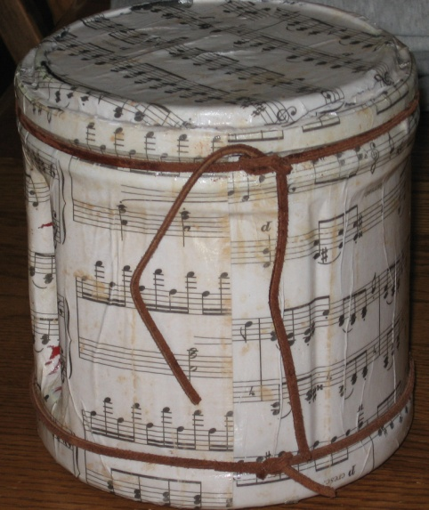

Day 2
- Have students get out their instrument they made on day 1.
- Review how to solve an algebra problem by finding the variable on the board. Example: x + 5 = 7.
- Demonstrate how to find the variable using your instrument. For example: in the problem above, x = 2, so I would beat the drum or shake the drum two times.
- Call on different students to answer different variable problems.
- Have the students create and write down 10 of their own variable problems and then choose a partner to solve each other’s work.
Assessment:
I walked around and did an informal assessment as students where sharing their problems with each other.
Extensions:
This lesson can be adapted to fit any content in any subject area. Examples:
Teacher Comments:
I also made a rain stick and use it for transitions, as a timer, and an attention getter.
Resources:
This lesson is adapted from Lesley University Instructor of Multiple Perspectives through Music professor Dawn Kolakoski.

